View in browser | Unsubscribe | Forward



Bioquarter Diversity and Inclusion

Technicians in the Bioquarter

 |  | Welcome to our special newsletter all about technicians' careers!  We are committed to promoting the careers of the excellent technicians working in the Bioquarter. If you are a technician or employ one read on to find out what is happening on our campus!

What is a technician?

“A technician is a person who is skilled in the use of particular techniques and procedures to solve practical problems, often in ways that require considerable ingenuity and creativity. Technicians typically work with complex instruments and equipment, and require specialised training, as well as considerable practical experience, in order to do their job effectively”

(Barley and Orr 1997)

The technicians' commitment

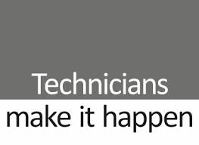 |  | The technicians' commitment is a university and research institution initiative, with support from the Science Council and the Technicians Make It Happen campaign, aiming to increase the visibility and recognition given to technicians, supporting their career development, and the sustainability of such careers. For more information see here

Technet in the QMRI

On 7th February 2019 there was an inaugural event for Bioquarter-based technicians. It was very well attended and participants discussed initial goals of the group and how to spread the aims to the whole campus.

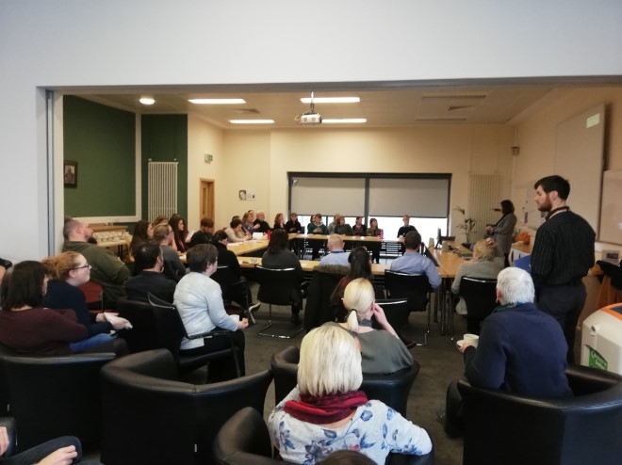

NEXT EVENT! Technicians' coffee morning

We would like to open our next event to all Technicians based at the Bioquarter so if you are interested in learning more about the technicians' commitment or meeting other technical staff, then come along to the Fyffe Room, QMRI, on Monday 17th June, 10.45-11.30. Drop in for a cup of coffee and a chat!  Biscuits and Cakes kindly provided by the Centre for Inflammation Research. |  | 

Nominate an outstanding technician!

Nominate an excellent technician you know for the Outstanding Technician of the Year award here - deadline June 5th! Look HERE for entry forms!

Contact us

University technicians website is HERE

To ensure you are kept informed of all technician-related news and events, there are university-wide technical staff and technical managers mailing lists. If you are not receiving these then please contact Val Gordon, Technician Commitment Project Coordinator - valerie.gordon@ed.ac.uk

For information on the coffee morning or more about how to support the Technicians' Commitment in the Bioquarter, contact Shonna Johnston - s.maccall@ed.ac.uk

For information about the Diversity and Inclusion team contact Emily Findlay - emily.findlay@ed.ac.uk

The University of Edinburgh is a charitable body, registered in Scotland, with registration number SC005336.
Unless explicitly stated otherwise, all material is copyright © The University of Edinburgh 2015.

