View in browser | Unsubscribe | Forward



Bioquarter Equality, Diversity & Inclusion and Athena SWAN

Welcome to the latest ECMS-Athena SWAN newsletter!
The Edinburgh Clinical Medical School (ECMS) consists of both the Clinical Sciences Deanery and the Molecular, Genetic & Population Health Sciences Deanery (MGPHS). We have active Athena SWAN (AS) Groups who strive to promote a culture of respect & inclusion of people from all backgrounds that nurtures excellence, career satisfaction, leadership and innovation.
Our bi-annual newsletters will keep you informed of where to seek advice, information on financial support, training courses and events. If you would like to find out more, please visit our website.

Lunchtime Forums

We were delighted that the recent forum on "Academic Progression: becoming a Professor" was so well attended, with over 32 staff gaining excellent advice from Callum Watson, HR on how to apply for promotion, as well as hearing from Prof. Lesley Forrester and Prof. Lorna Marson about their own academic and clinical academic experiences.

Our next lunchtime forum in on Wednesday 22 January and addresses "Professional Services Staff: Career development". Whilst the event is now fully booked, we will post the speaker's slides onto the website.

If you have any ideas for future topics and speakers, please let Femke Morrison (Femke.Morrison@ed.ac.uk) know.

Dignity and Respect Advisors

We will be holding interviews this week to recruit Dignity and Respect Advisors (DRA) for the ECMS. DRAs are voluntary roles taken on by existing staff, as part of the University’s commitment to promoting dignity and respect.
We look forward to announcing who will be our DRA volunteers, but in the meantime, if you wish to find out further information on the University's D&R Policy, please visit the Staff News Webpage or alternatively please email equalitydiversity@ed.ac.uk.

Inspiring People 2020

 |  | Following the success of Inspiring People 1, 2 and 3 - we are delighted to announce that the Deaneries of MGPHS and CS, have agreed to support a fourth Inspiring People Day. The day will encourage all staff and students to embrace and promote Equality and Diversity as the best way for everyone to achieve their career potential. More details to follow!

ECMS Athena SWAN Survey

Huge thanks to everyone who filled out the survey!  We had a record return with the overall rate being approximately 98% for Deaneries of Clinical Sciences and 84% for Molecular, Genetic and Population Health Sciences respectively.  Having such a large response, allows us to get a really good understanding of the views from staff for the following categories:  Support & Engagement, Career Development & Promotions, Social & Gender Equality, Management, Information & Awareness, Culture and Equal Participation.  We are currently assessing the positive impact that the ECMS AS events, forums and grants have made, and are also identifying categories where further work is required. We will then create an action plan for the next 2 years, until 2022. |  | 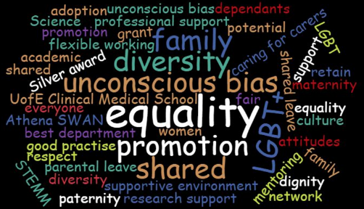

Caring for Carers - benefits of receiving the grant

As many of you are aware, the ECMS AS Committee accepts applications from ALL employees, who have a caring responsibility and require funding and support, so that they can balance work with caring commitments and continue to be effective in their role.

We are delighted to highlight feedback from a couple of our recipients:

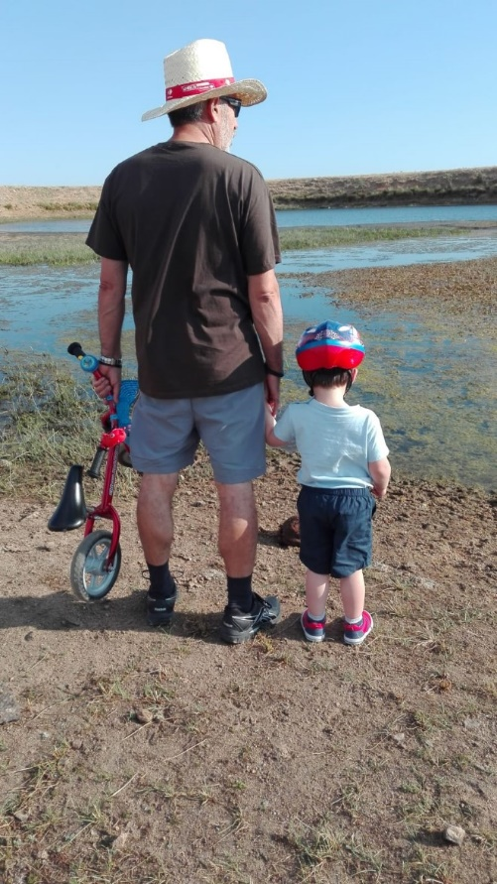 |  | My name is Sofia, currently a post-doctoral researcher, at the Centre for Regenerative Medicine. As a postdoc who would like to progress in academia presenting data at international conferences is always a priority.  However, as my husband commutes every day to Glasgow, I am the primary carer of our son. To me, this means that my day revolves around the schedule of the nursery. I cannot start bench work before 8 am nor finish after 5 pm because, otherwise, nobody will pick up our son. We both moved to Edinburgh in 2013, and all our family is in Spain, so we have no external help. In this situation, the idea of attending an international conference was unimaginable.  The Carer’s Conference Grant allowed me to take my son with me to Spain, where the grandparents enjoyed a wee holiday with him while I attended the conference in Lisbon. The application was simple and the response very quick.  Overall it was a great experience, the conference was fantastic, and the collaborations established invaluable. I would highly recommend applying to this scheme to any parent who needs a back up to boost their career.

My name is Emma, a postdoctural researcher, who works condensed hours Tuesday-Friday, since returning from maternity leave.  As my research focuses on cilia and microtubule-based structures, I was very keen to attend the Microtubule Meeting on Monday 19th April.  Fortunately, the Caring for Carers grant allowed me to pay for childcare, which meant I could attend the meeting to present my poster, as well as network with experts in my field.  Further information is available on our website. |  | 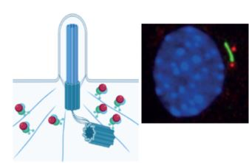

Bioquarter Pride

Some good news - the bake sale last semester raised £405.03 for Stonewall!  Events are now being organised for LGBT+ history month - while dates are still being scheduled, they will likely be in the first week of February, so keep your eyes peeled for future announcements. For more details please contact gareth.hardisty@ed.ac.uk |  | 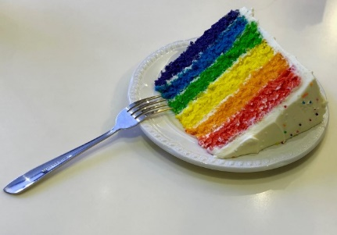

For details about ECMS Athena SWAN, please email: AthenaSwan_DCS_DMGPHS@ed.ac.uk
For information on the Career Satisfaction & Progression committee - contact P.Fitch@ed.ac.uk
For information on the EDI-AS Bioquarter committee - contact emily.findlay@ed.ac.uk

