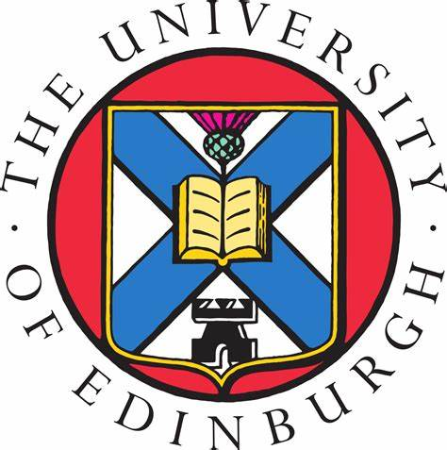 | The University of Edinburgh  College of Medicine and Veterinary Medicine

PReDICTED GRADES REQUEST FORM
INDIA - ALL INDIA SENIOR SCHOOL CERTIFICATE EXAMINATION (SSC), INDIAN SCHOOL Certificate (ISC), higher secondary certificate (HSC) OR SENIOR SECONDARY SCHOOL certificate (SSSC)
Standard XII

Please complete this form electronically where possible

Name of Applicant:
UCAS Personal ID Number:
School Name & Address:

PREDICTED OVERALL AVERAGE GRADE (%)

Class XII Subjects |  | Predicted Grades (%)
Subject
Subject
Subject
Subject
Subject
Subject
Subject
Subject
Subject
Subject

Teacher’s Name: | Teacher’s Signature: | Date:

